Assignment No -: 08

Que 1 -: Assume each salesperson has a 12% commission write a query on the orders table that will produce the order number the salesperson number and the amount of the salesperson’s commission for that order.

kd2_83598>select salespeople.Snum,orders.onum,orders.amt,salespeople.comm,0.12*orders.amt "commissionAmount" from orders,salespeople
-> where salespeople.Snum=orders.snum
-> order by 1;
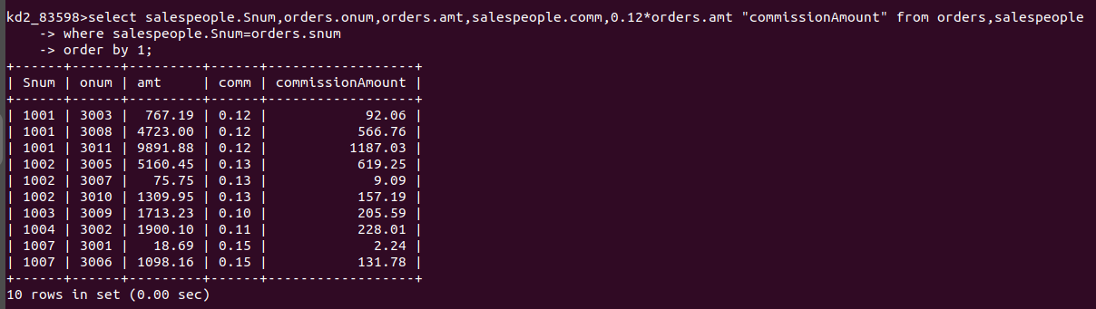

Que 2-: Write a Query on the Customers Table that will find the highest rating in each city put the output in this form .
For the city(city),The Highest Rating is (Rating)

kd2_83598>select city"for the City",max(Rating) "The Highest Rating" from Customers
-> group by City;

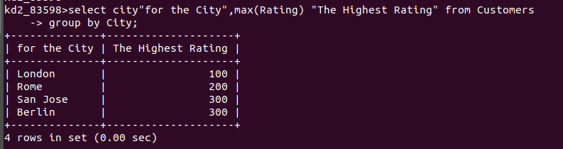
Que 3 -: write a query That lists customers in descending order of rating. Ouput the rating field first followed by customers name and number.

kd2_83598>select Rating,Cname,Cnum from Customers
-> order by Rating desc;

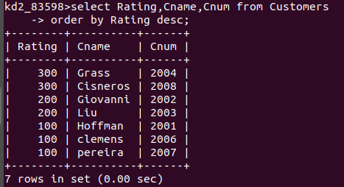

Que 4-: Write a query that totals the orders for each day and places the result in descending order.

kd2_83598>select count(onum),odate from orders
-> group by odate
-> order by count(onum) desc;

